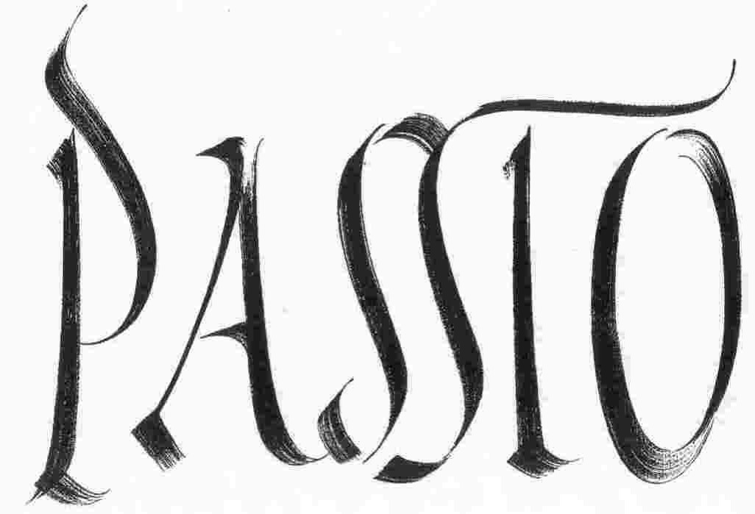

PRELIMINARY INFORMATION FOR PROMOTERS

Isabella Rossellini presents
a Peter Limburg / Livio Jacob Production
PASSIO
THE MUSIC

Jesus: Baritone
Pilatus: Tenor

Evangelist Quartet:
Soprano
Alto
Tenor
Bass

Mixed choir (12-15 singers)

Organ

Violin
Oboe

Cello
Bassoon

Conductor
PASSIO
THE FILM

Format: 35mm, silent, black & white / color / handcoloring

Length: 6,611 ft. + 11 frames (2,015.4 metres), seven single reels merged into four doubles

Running time: 74 minutes

Aspect ratio: silent full aperture

Projection speed: 24 fps

Passio was struck into seven 35mm handcolored prints:

THE COOL COLORS
Print 1……….Ruby
Print 2……….Violet
Print 3……….Indigo
Print 4……….Magenta

THE WARM COLORS
Print 5……….Vermilion
Print 6……….Minium
Print 7……….Gold

A full technical rider for the project is available from Svend Brown Music Projects

PASSIO
BOOKINGS AND TECHNICAL REQUIREMENTS

The Passio project (music and film) is managed by Svend Brown Music Projects.

For information on bookings and performance fees, please contact:

Svend-Einar Brown
Music Projects
7 Corstorphine House Terrace
Edinburgh
EH12 7AE United Kingdom

Tel. +44-7736-336766
Fax: 0044 131 556 0277
Email: svend@svendbrown.com
Web: www.svendbrown.com

Please note:
The organizing venue must be able to provide – or be equipped with – one (platter) or two (changeover) 35mm projectors at standard sound speed. The projectors must be equipped with silent full aperture and operated by a qualified projectionist. As the film is silent, no sound amplification is necessary.

PASSIO
THE PROJECT

Arvo Pärt’s Passio, one of the last masterpieces of 20th century music, has inspired a silent film on the impending crisis of our visual culture, a dramatic meditation on the act of seeing.

In 1895, about forty minutes of moving images were produced. Most of this still survives. In 2004, more than two billion viewing hours of moving images were made. This translates into 228,000 viewing years of films, video and television programs, advertising shorts, videogames, news broadcasts, security videos, home movies and the like. Over 95 percent of these moving images produced each year are lost forever, and the rate of oblivion is bound to further increase.

What is the urge to create visions all about? Are there such things as the art and ethics of viewing? What is the difference between looking at the fragment of an obscure film, at the video footage of a surveillance camera, at the home movie of a family we know nothing about, or at the torn papyrus of an ancient illustrated manuscript?

The images for this work have been chosen from the countless manifestations of our neglected or repressed collective memory, ranging from documents of political and racial oppression to scientific experiments, depictions of human suffering turned into mass spectacle, and the deliberate destruction of moving images.

More than an accompanied silent film of our lost visual memory, more than a music concert supplemented by cinema, Passio is a meditation, a ritual where hearing and seeing become a unified entity, an emotionally powerful and striking oratorio for moving image and sound.
PASSIO
BIOGRAPHIES

PAOLO CHERCHI USAI
Film curator, critic, and writer. He is Director of the National Film and Sound Archive of Australia, co-founder of the Pordenone Silent Film Festival and of the L. Jeffrey Selznick School of Film Preservation at George Eastman House in Rochester, New York. He is the author of books and essays on film history, digital culture, and moving image preservation. Among his published works are “Before Caligari“ (co-editor, 1990); Burning Passions: An Introduction to the Study of Silent Cinema” (revised edition, 2000); “The Death of Cinema” (2001).

PAUL HILLIER
Paul Hillier is one of the world’s foremost choral conductors. He is Artistic Director and Principal Conductor of the Estonian Philharmonic Chamber Choir (EPCC), Founder and Director of Theatre of Voices and Chief Conductor of Ars Nova Copenhagen. He co-founded The Hilliard Ensemble and during his tenure as musical director the group rose to international prominence. Hillier enjoys close creative relationships with many living composers, most notably Steve Reich and Arvo Pärt, both of whom have written works for him to perform with his various ensembles. Alongside projects with his own ensembles, he enjoys guest conducting with many of the world’s finest choirs. Recent recordings include Rachmaninov’s Vespers with the EPCC on Harmonia Mundi, which has already been welcomed with critical praise.

BRODY NEUENSCHWANDER
Brody Neuenschwander discovered his love of calligraphy very early. It pursued him through his years at Princeton University and the Courtauld Institute in London, where he received a doctorate in art history in 1986. Given the choice between the life of an academic and that of a craftsman, he chose the latter. But his calligraphy refused to stay within the limits imposed on it by western culture. He studied the principles of Chinese and Arabic calligraphy and began to apply these to the Latin alphabet. The work of Cy Twombly and Jenny Holzer pointed to new possibilities. It was Neuenschwander’s work with Peter Greenaway that pulled all these strands together. In 1991 he created the live calligraphy for the film «Prospero’s Books». This was followed by «The Pillow Book», «Flying Over Water»(exhibition, Malmo, Sweden), «Columbus» (opera, Berlin), «Writing to Vermeer» (opera, Amsterdam and New York), «Bologna Towers 2000» (sound and light installation, Bologna) and many other projects.

PASSIO
ABOUT THE FILM

It has been noted that the music of Arvo Pärt is capable of transporting listeners to a moment outside time; Paolo Cherchi Usai’s film has succeeded in accomplishing something equally miraculous. He confronts with imagery which reminds us without remorse of our species’ evidently limitless capacity for inflicting suffering upon each other. At the same time, there’s something mysteriously beautiful about this work, something unlike anything we’ve seen before – and that in itself occasions an almost celebratory sense of a rebirth of hope.
Peter Scarlet, Executive Director, Tribeca Film Festival

From Epstein to Godard, from Antonioni to Wenders and beyond, there is a rich and cherished tradition of passionate cinephiles moving from critical writing towards filmmaking. Another, more recent, tradition has shown us the artistic riches that can be gained by re-working existing film material, by transforming “found footage” into new and exciting works of film art. A third tradition, finally, has sought to combine the recorded medium of film with the live art of making music and to create a synesthetic event in the process; this endeavour usually takes the form of writing and playing new music to accompany (and thus interpret) a film which already exists. I am marshalling these seemingly unrelated forces and pathways of film history because, against all odds, Passio represents the exact and surprising point of intersection between them. Furthermore, Cherchi Usai has carved out a decidedly unconventional approach on each of the three traditions, twisting and twirling them into a strange new work (of beauty and philosophy and of open questions) which has practically no precedent in cinema.
Alexander Horwath, Director, Österreichisches Filmmuseum

Paolo Cherchi Usai’s Passio is a non-pareil passion of suffering, pain, and lost love; yet it also reaches out and touches us with its sorrow and compassion for our troubled world. This is neither a film nor a musical performance; it is a creative mystery of unsettling visuals and vibrant sound to create an indelible experience.
Adrienne Mancia, Curator-at-large, BAM Cinématek

After having seen Passio, I felt as if all the experimental cinema we are familiar with had become a thing of the past. “Past” does not mean obsolete, as Cherchi Usai has updated some of the avant-garde’s protocols – the black screen and the calligraphy, the archival footage and the handcoloring. What I had never experienced before, however, is the film’s finely calibrated structure, reminiscent of J.S. Bach’s dazzling architectures of sounds and mathematics. Nor have I ever witnessed a film which not only presents itself as a stand-alone commentary of a pre-existing work of music, but also strives to exist exclusively within the unique context a live performance, an ever-changing aural landsdcape from one concert to another. In aesthetic terms, this strategy results in a proliferation of meanings, a vertigo effect on the “passion” of the soul, of the body, of cinema itself. Un chien andalou meets Gianikian and Ricci Lucchi. Together, they celebrate the epiphany of a new auteur.
Alberto Barbera, Director, Museo Nazionale del Cinema, Turin

As a visual accompaniment to the extraordinary oratorio by Arvo Pärt, performed live by The Theatre of Voices, Cherchi Usai's silent feature Passio takes this musical experience into the sublime. Using found footage from across the 20th century, this stunning and at times confronting work forces us to examine man's inhumanity to man – and his seeming contempt for nature and the natural – through the merciless lens of the camera, recontextualizing the story of the Passion of Christ for our times. Beautiful, shocking and full of wonders.
Katrina Sedgwick, Director, Adelaide Festival of the Arts

Passio is nothing you are quite prepared to see when the lights go out – or talk about when they return. It is not your conventional movie of course, but neither is it an unconventional movie in a conventional sense. It includes shots from cinema’s early days, but none of the kind which could possibly cause nostalgia for those days; Passio is a film born in a film archive, yet it is not an autumnal elegy about image decay. It includes written words that refuse to be read, it is made to music which is not part of the film, and, unlike any other movie I have seen, it offers space not only for visuals but also for visual echoes which opticians call “afterimages.” We have standards for everything, including – let’s face it – a standard for novelty. Passio does not fit there; it’s a new kind of cinema in a new kind of sense.
Yuri Tsivian, Professor of Film, University of Chicago

There are many narrow paths between the cinematic territories of mondo-shockumentary and Luis Buñuel. They are dark and often dangerous, but one can take the right one as long as it is illuminated by the divine light of love. As a film historian and curator, Paolo Cherchi Usai firmly believes in this metaphysical power, and proves that transcendence can be found in the most ephemeral archival footage, projected through the light of Arvo Pärt.
Hisashi Okajima, Chief Curator, National Film Center, Tokyo

PASSIO
THE CREDITS

ISABELLA ROSSELLINI
PRESENTS

A PETER LIMBURG / LIVIO JACOB
PRODUCTION

PASSIO

A FILM BY
PAOLO CHERCHI USAI

WITH THE PARTICIPATION OF
CINEMATECA BRASILEIRA
DANISH FILM INSTITUTE
DEUTSCHES INSTITUT FÜR FILMKUNDE
FILMMUSEUM BERLIN
FILMOTECA DE LA UNAM
GEORGE EASTMAN HOUSE
LIBRARY OF CONGRESS
NATIONAL FILM AND SOUND ARCHIVE
NEW ZEALAND FILM ARCHIVE
NGA KAITIAKI O NGA TAONGA WHITIAHUA

CALLIGRAPHY AND HANDCOLORING
BRODY NEUENSCHWANDER

ASSISTANT DIRECTOR
CHAD D. HUNTER

EXECUTIVE PRODUCER
JACQUES L’AUMÔNE

FILM EDITOR
RAQUEL SATUMALAIJ

LABORATORY PROCESSING
JUAN VRIJS

PASSIO
THE CREDITS (continued)

OPTICAL PRINTING
BRIGITTE PAULOWITZ

VISUAL EFFECTS
GERARD DE HAAN
PAULO FONSECA

THIS FILM WAS PRODUCED
ON EASTMAN KODAK
35MM MOTION PICTURE FILM STOCK
AND EDITED WITH MANUAL EQUIPMENT.
THE ORIGINAL NEGATIVE
WAS DESTROYED BY THE AUTHOR
AFTER THE CREATION OF
SEVEN HANDCOLORED PRINTS.

IN MEMORY OF
JONATHAN DENNIS
(1953-2002)

© MMVI PAOLO CHERCHI USAI

